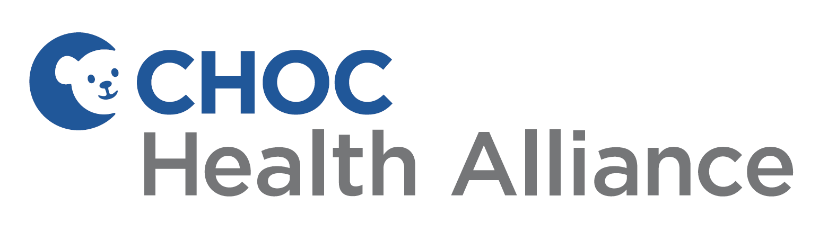

ENCHANCED CARE MANAGEMENT (ECM)

SELF REFERRAL FORM

We’re glad you found us!
Enhanced Care Management (ECM) is a free service through Medi-Cal designed to help access the care and support needed for a healthy life.
Please complete the form and email to ECM@choc.org or contact CHOC Health Alliance Customer Service at 1-800-424-2462 with any information that may be helpful in deciding if the ECM program is the right fit. Forms are reviewed weekly. You will be contacted by a CHOC Health Alliance team member after our team reviews this information to talk about the program. You can also email us at ECM@choc.org or call CHOC Health Alliance Customer Service at 1-800-424-2462 with any questions you have.
Date of submission: ________________________
Member name: ________________________________________________________________________________
DOB: _______________________________
Name of person submitting this form: ___________________________________________________________
Contact information: ___________________________________________________________________________
Relationship to member: Parent Guardian Self Other (please explain below)
If “other” please describe your relationship to member here: ____________________________________
How can the ECM program help you? Choose below:
☐ Are you or your children experiencing homelessness?
☐ Is your child frequently seen the Emergency Department or hospitalized?
☐ Does your child have serious mental health or substance use needs?
☐ Is or has your child been involved in Foster Care?
☐ Is your child enrolled in CCS and has additional needs?
☐ Are you under 21 years old and pregnant?

