

ENHANCED CARE MANAGEMENT (ECM)

PROVIDER REFERRAL FORM

Thank you for your interest in the ECM program for your patient! Please complete the following information to facilitate review of possible ECM eligibility.
Please email the completed form to ECM@choc.org or contact CHA Customer Service at 1-800-424-2462. Please provide any supporting documentation that may be helpful in determining eligibility.

Date of submission: Click or tap to enter a date.
Member name: Click or tap here to enter text.
DOB: Click or tap to enter a date.
MRN: Click or tap here to enter text.
Medi-Cal ID #/CIN#: Click or tap here to enter text.
Requestor and title:
Requestor’s contact information: Click or tap here to enter text.
Brief reason for referral: Click or tap here to enter text.
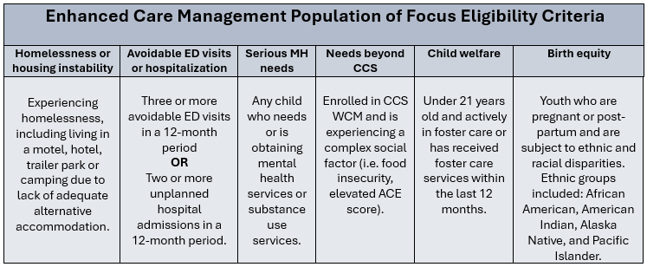
Population of Focus (POF) (See descriptions below. Choose from drop-down list): Choose an item.

Additional information:
Click or tap here to enter text.

